# Session 1 Tutor’s Guide

## Data-Driven Decision Making with and without Probabilities

1. Suppose that a decision maker faced with four decisions alternatives and four states of nature develops the following profit payoff table:

|  |  |  |  |  |
| --- | --- | --- | --- | --- |
|  | **State of Nature** | | | |
| **Decision**  **Alternatives** | S1 | **S2** | **S3** | **S4** |
| D1 | 14 | 9 | 10 | 5 |
| D2 | 11 | 10 | 8 | 7 |
| D3 | 9 | 10 | 10 | 11 |
| D4 | 8 | 10 | 11 | 13 |

What is the recommended decision using the optimistic, conservative and minimax regret approaches?

|  |  |  |
| --- | --- | --- |
| Decision | Maximum Profit | Minimum Profit |
| D1 | 14 | 5 |
| D2 | 11 | 7 |
| D3 | 11 | 9 |
| D4 | 13 | 8 |

Optimistic approach: select *D1*

Conservative approach: select *D3*

|  |  |  |  |  |  |
| --- | --- | --- | --- | --- | --- |
|  | *s1* | *s2* | *s3* | *s4* | Minimax Regret |
| D1 | 0 | 1 | 1 | 8 | 8 |
| D2 | 3 | 0 | 3 | 6 | 6 |
| D3 | 5 | 0 | 1 | 2 | 5 |
| D4 | 6 | 0 | 0 | 0 | 6 |

Minimax regret approach: select *D3*

1. An owner of a campsite is trying to decide whether to build a swimming pool, a tennis court or an indoor bar area. She can only afford to build one of these and she needs help in deciding which one to choose. The profitability of each will to some extent depend on the weather. If the weather is hot, campers would prefer the swimming pool, but if the summer is cool, an indoor bar will be more profitable. The owner has estimated the annual profitability (in $1000s) for each option for three states of nature (the weather) as shown in below.

|  |  |  |  |
| --- | --- | --- | --- |
|  | **Weather** | | |
| **Hot** | **Average** | **Cool** |
| **Swimming pool** | 100 | 50 | 30 |
| **Tennis court** | 70 | 90 | 40 |
| **Indoor Bar** | 50 | 100 | 170 |

What is the recommended decision using the optimistic, conservative and minimax regret approaches?

|  |  |  |
| --- | --- | --- |
| Decision | Maximum Profit | Minimum Profit |
| Swimming pool | 100 | 30 |
| Tennis court | 90 | 40 |
| Indoor Bar | 170 | 50 |

Optimistic approach: Build indoor bar

Conservative approach: Build indoor bar

|  |  |  |  |  |
| --- | --- | --- | --- | --- |
|  | Weather | | | Minimax Regret |
| Hot | Average | Cool |
| Swimming pool | 0 | 50 | 140 | 140 |
| Tennis court | 30 | 10 | 130 | 130 |
| Indoor Bar | 50 | 0 | 0 | 50 |

Minimax regret approach: Build indoor bar

If the probability of a hot summer is 0.2 and that of a cool summer is 0.35, draw a decision tree to describe the scenario and hence calculate the best decision using the expected value approach.

Probability of an average weather = 1 – 0.2 – 0.35 = 0.45

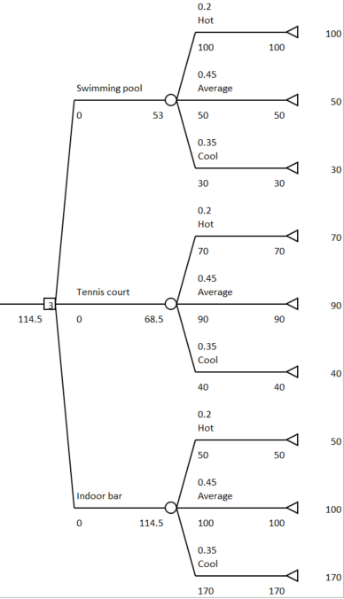

EV(Swimming pool) = 0.2(100) + 0.45(50) + 0.35(30) = 53

EV(Tennis court) = 0.2(70) + 0.45(90) + 0.35(40) = 68.5

EV(Indoor bar) = 0.2(50) + 0.45(100) + 0.35(170) = 114.5 (recommended option)

1. An investment trust manager wishes to buy a portfolio of shares and he has sufficient funds to buy either portfolio A, B or C. The potential gains from the portfolio will depend on the economy over the next 5 years and estimates (in $1000s) have been shown below:

|  |  |  |  |
| --- | --- | --- | --- |
|  | **Growth** | **Stable** | **Recession** |
| **A** | 5 | 2 | -2 |
| **B** | 4 | 7 | -4 |
| **C** | 4 | 4 | 4 |

What is the recommended decision using the optimistic, conservative and minimax regret approaches?

|  |  |  |
| --- | --- | --- |
| Decision | Maximum Profit | Minimum Profit |
| A | 5 | -2 |
| B | 7 | -4 |
| C | 4 | 4 |

Optimistic approach: Buy portfolio B

Conservative approach: Buy portfolio C

|  |  |  |  |  |
| --- | --- | --- | --- | --- |
|  | Economy | | | Minimax Regret |
| Growth | Stable | Recession |
| A | 0 | 5 | 4-(-2)=6 | 6 |
| B | 1 | 0 | 4-(-4)=8 | 8 |
| C | 1 | 3 | 0 | 3 |

Minimax regret approach: Buy portfolio C

If the manager estimate that the probability of the economy will grow over the next 5 years is 0.5 while the probability of a recession is 0.2, calculate the best decision using the expected value approach.

Probability of a stable economy = 1 – 0.5 – 0.2 = 0.3

EV(A) = 0.5(5) + 0.3(2) + 0.2(-2) = 2.7

EV(B) = 0.5(4) + 0.3(7) + 0.2(-4) = 3.3

EV(C) = 0.5(4) + 0.3(4) + 0.2(4) = 4

Recommendation : to purchase portfolio C